

Correlation Tables showing Relationships between the Marine Habitat Classification for Britain and Ireland (v22.04) and Other Classifications

User Guide

January 2026

https://mhc.jncc.gov.uk/

Contents
Introduction 2
Important Information 2
User guide – Spreadsheet version 3
Key updates to this version of the correlation tables 4
Addition of new classification systems 4
Corrections and updates 4

Introduction

The correlation tables allow users to identify possible relationships between marine habitats listed in the JNCC Marine Habitat Classification for Britain and Ireland, other marine habitat classifications (e.g. EUNIS, Annex I habitats, OSPAR habitats). The correlation tables are periodically revised as habitat definitions are refined. The correlation spreadsheet is currently the only tool publicly available to investigate these correlations. This document provides a user guide to the spreadsheet version.

Important Information

The following information is important to understand before using the correlation tables. This information can also be found in the ‘Read me’ of both the spreadsheet and database versions of the correlation tables.

The correlation tables included show relationships between the following classifications:
- Marine Habitat Classification for Britain and Ireland (v2204, v1503, v0405, v9706)
- EUNIS habitat classification (2022, 2007)
- OSPAR List of Threatened and/or Declining Species & Habitats
- Habitats Directive Annex 1 Features
- Habitats of Principal Importance
- MCZ Habitat Features of Conservation Importance (FOCI)
- Priority Marine Features (Scotland)
- MCZ Broad-Scale Habitats (BSH)
- Marine Strategy Framework Directive Benthic Broad Habitats 2017
- Bern Convention Emerald habitats
- Global Ocean Observing System Essential Ocean Variables
- Vulnerable Marine Ecosystems
- Global Ecosystem Typology

Habitats are correlated using the following relationship types:

Habitats included in JNCC v2204 | Correlation Type | Habitats in the defined classification | Meaning
X | Is the same as | Y | Habitat X is the same as or equal to Habitat Y
X | Contains | Y | Habitat X has wider definition than Habitat Y
X | Is contained within | Y | Habitat X has narrower definition than Habitat Y
X | Partially overlaps with | Y | Habitat X definition partially overlaps with that of Habitat Y
X | BLANK | Y | Habitat X is not linked with Habitat Y

User guide – Spreadsheet version

Important information is listed on the “Read me” tab. The “Correlation Data” tab of this spreadsheet version of the correlation table can be used to correlate JNCC Marine Habitat Classification habitats with equivalent habitats from other classifications. The top row of the table shows the codes, names, levels and relationships of listed habitat which can be correlated. Correlations are only given for habitats which occur in the UK. The correlation table lets you select one or more habitats using the drop-down list on the top row to filter. You can also filter habitats at a certain level using the drop-down list at the top of each classification’s ‘level’ column.

The spreadsheet is divided by classification. Each relationship column shows the relationship between the JNCC Marine Habitat Classification v2204 and the listed habitat with relationship types as described in the important information (e.g. Is the same as). Where no correlation applies, the corresponding cell is blank (Figure 1). The JNCC v2204 columns are frozen to allow for quick comparison.

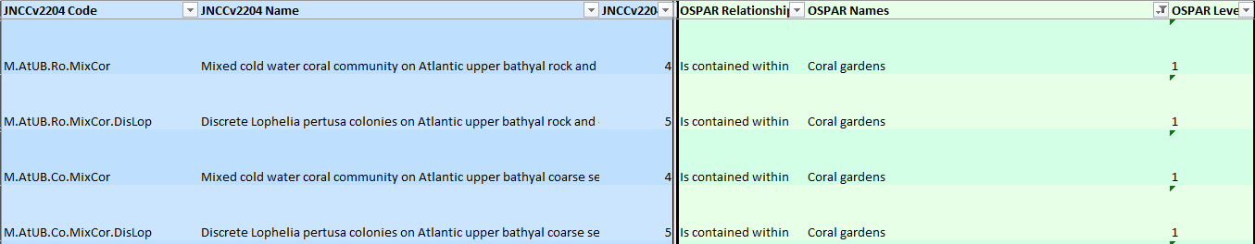
Figure 1: Extract from the Marine Correlation Tables Spreadsheet version showing selected JNCC v2204 coral communities on upper bathyal rock are ‘contained within’ OSPAR coral gardens.

Key updates to this version of the correlation tables

Addition of new classification systems

- 22.04 version of the JNCC Marine Habitat Classification for Britain and Ireland
- 2022 version of the EUNIS marine habitat classification
- Bern Convention Emerald habitats
- Global Ocean Observing System Essential Ocean Variables
- Vulnerable Marine Ecosystems
- Global Ecosystem Typology level 3 ecosystem functional groups with relationships identified by JNCC for the Global Biodiversity Framework in 2025.

Corrections and updates

As the correlation tables are revised, notes of changes will be made to this section. There are currently no changes listed.

Change | Rationale
e.g. Change in code | e.g. reclassification of previous biotope

